Canadian University Dubai

**Token Dispensary Project**

Abdulla Sharif (20160004770)

Bakhodir Ulugov (20190007574)

Professor Said El Naffar

Faculty of Engineering, Applied Sciences and Technology

Abstract

This project is meant to educate us on the use of request and FastAPI modules in Python along with PySimpleGUI. The objective is to allow clients to print tokens to join a customer queue, of which service agents will be notified and can request to serve a customer once on duty. Data is compiled in a dictionary format on the API which calculates number of tokens, average waiting time and such for a statistical report. The tokens themselves are serialized uniquely and display the current date and time.

# Graphical Interfaces

Both interfaces were created using the PySimpleGUI module and the logos were taken from Aster Pharmacy (photoshopped for transparency and size). The client UI is simply a button box whereas the agent UI utilized multilines and more button boxes.

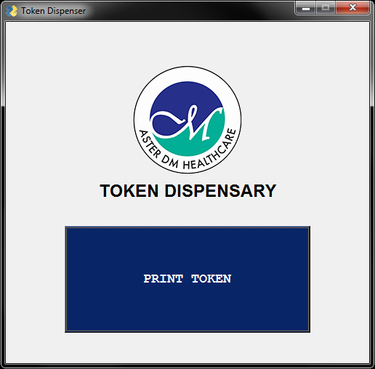

Fig. 1) Client GUI.

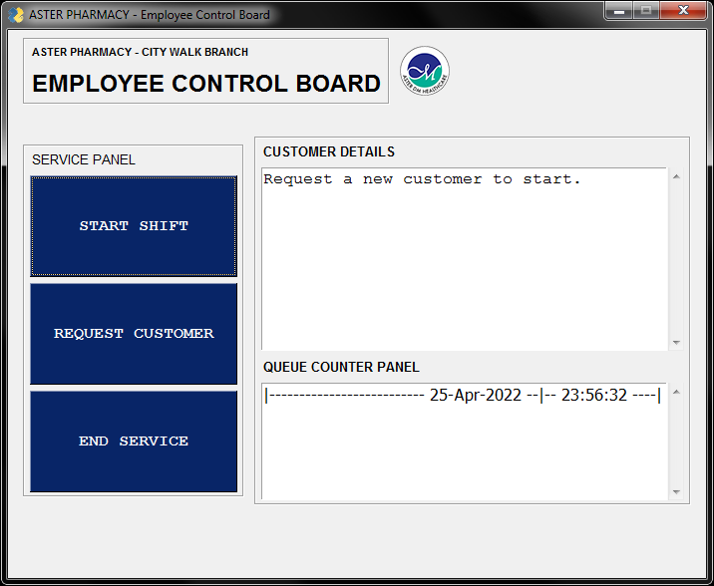

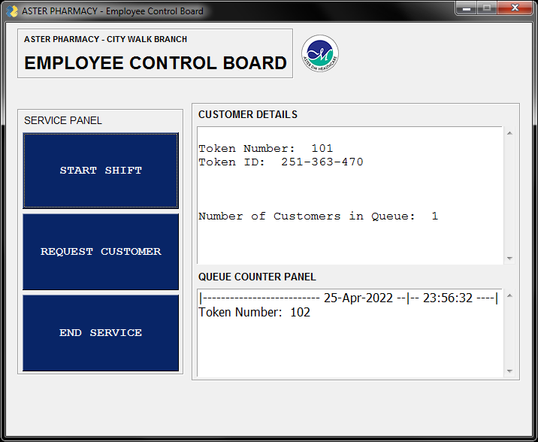

Fig. 2) Agent GUI, default. Fig. 3) Agent GUI, during service.

## FastAPI1

[To add a table of contents (TOC), apply the appropriate heading style to just the heading text at the start of a paragraph and it will show up in your TOC. To do this, select the text for your heading. Then, on the Home tab, in the Styles gallery, click the style you need.]

### [Heading 3].

[Include a period at the end of a run-in heading. Note that you can include consecutive paragraphs with their own headings, where appropriate.]

#### [Heading 4].

[When using headings, don’t skip levels. If you need a heading 3, 4, or 5 with no text following it before the next heading, just add a period at the end of the heading and then start a new paragraph for the subheading and its text.] (Last Name, Year)

##### [Heading 5].

[Like all sections of your paper, references start on their own page. The references page that follows is created using the Citations & Bibliography feature, available on the References tab. This feature includes a style option that formats your references for APA 6th Edition. You can also use this feature to add in-text citations that are linked to your source, such as those shown at the end of this paragraph and the preceding paragraph. To customize a citation, right-click it and then click Edit Citation.] (Last Name, Year)

References

Last Name, F. M. (Year). Article Title. *Journal Title*, Pages From - To.

Last Name, F. M. (Year). *Book Title.* City Name: Publisher Name.

Footnotes

1[Add footnotes, if any, on their own page following references. For APA formatting requirements, it’s easy to just type your own footnote references and notes. To format a footnote reference, select the number and then, on the Home tab, in the Styles gallery, click Footnote Reference. The body of a footnote, such as this example, uses the Normal text style. (Note: If you delete this sample footnote, don’t forget to delete its in-text reference as well. That’s at the end of the sample Heading 2 paragraph on the first page of body content in this template.)]

Tables

Table 1

[Table Title]

|  |  |  |  |  |
| --- | --- | --- | --- | --- |
| Column Head | Column Head | Column Head | Column Head | Column Head |
| Row Head | 123 | 123 | 123 | 123 |
| Row Head | 456 | 456 | 456 | 456 |
| Row Head | 789 | 789 | 789 | 789 |
| Row Head | 123 | 123 | 123 | 123 |
| Row Head | 456 | 456 | 456 | 456 |
| Row Head | 789 | 789 | 789 | 789 |

Note: [Place all tables for your paper in a tables section, following references (and, if applicable, footnotes). Start a new page for each table, include a table number and table title for each, as shown on this page. All explanatory text appears in a table note that follows the table, such as this one. Use the Table/Figure style, available on the Home tab, in the Styles gallery, to get the spacing between table and note. Tables in APA format can use single or 1.5 line spacing. Include a heading for every row and column, even if the content seems obvious. A default table style has been setup for this template that fits APA guidelines. To insert a table, on the Insert tab, click Table.]

Figures title:

Figure 1. [Include all figures in their own section, following references (and footnotes and tables, if applicable). Include a numbered caption for each figure. Use the Table/Figure style for easy spacing between figure and caption.]

For more information about all elements of APA formatting, please consult the APA Style Manual, 6th Edition.